Youth Ministry Co-ordinator
Recruitment Pack
April 2024

Team: | Learning & Engagement
Location: | Chichester Cathedral
Contract Type: | Permanent
Hours: | Part time – 0.6 FTE
Salary: | £16,200 [FTE £27,000]

Any questions?
Head of HR, Val Timlin
val.timlin@chichestercathedral.org.uk

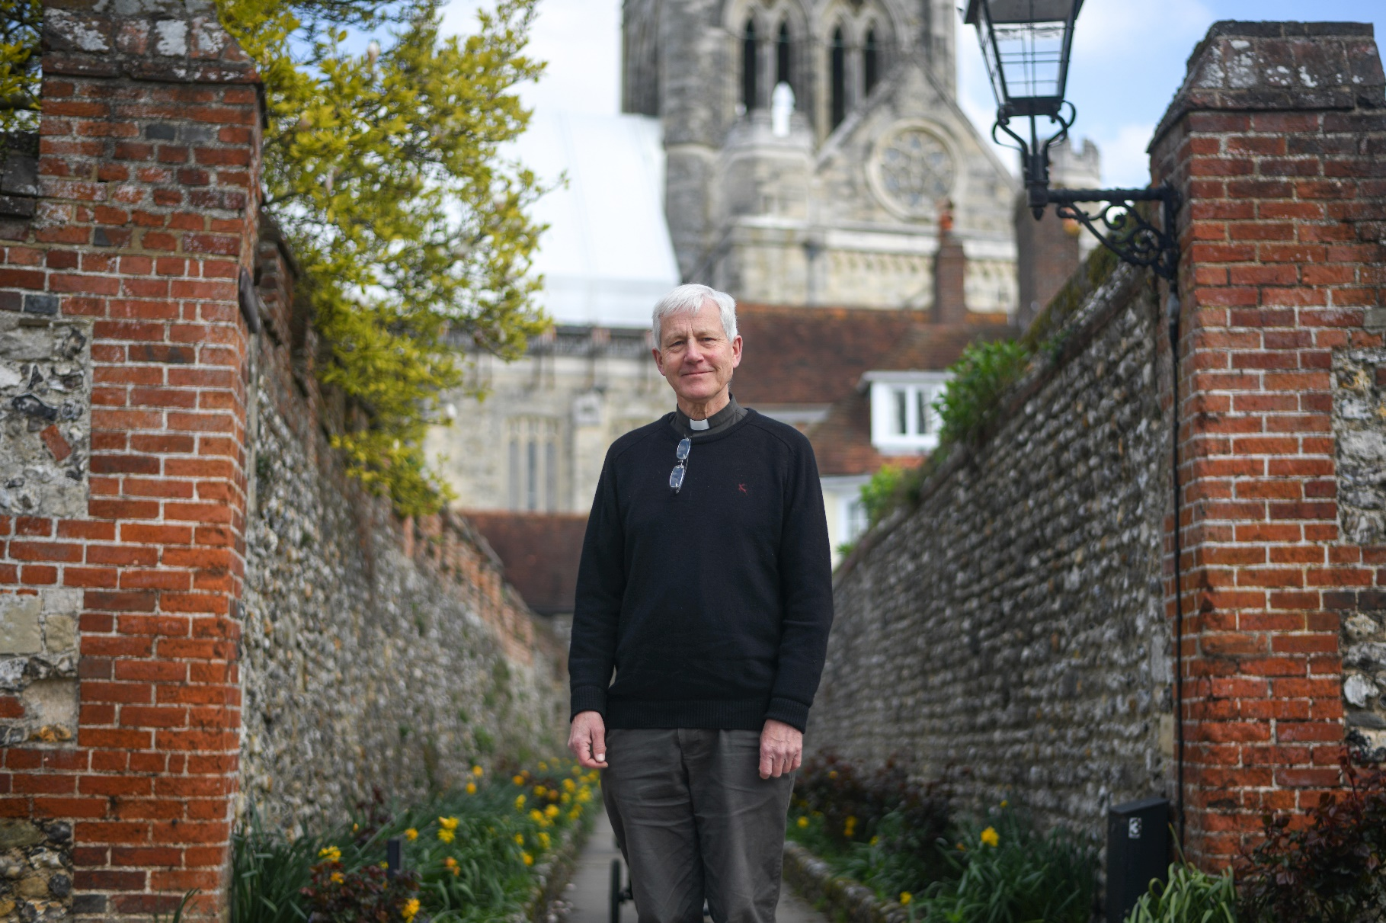

Welcome from the
Interim Dean of Chichester

Dear candidate
Thank you for your interest in this post.
Chichester Cathedral values Christian education for all ages, and now wishes to expand its work with families and young people. This post offers scope for nurturing the faith of children and young people in collaboration with Cathedral colleagues and with a range of other partners, including the Diocese, local schools and churches.
We are looking for candidates who are creative, self-motivated, imaginative, and enthusiastic about sharing the Gospel. In return, we are offering the chance to work as part of a unique community of faith, centred around a building of immense spiritual power.
The Cathedral is at a time of change and opportunity, awaiting the arrival of a new Dean and preparing to celebrate our 950th anniversary in 2025. We are at the heart of a beautiful city, close to the Downs and the sea, with its own university and college and a wide mix of schools. Our population includes many children and young people, and an increasing number of them attend our 9.15 Eucharist each Sunday.
There is huge potential to develop Christian education here in Chichester, and we wish to do all that we can to fulfil it. If you are excited by our vision and feel that you could use your gifts and experience to help us, we would love to hear from you.
Please be assured that you are in our prayers.

The Reverend Canon Simon Holland
Interim Dean of Chichester
About Chichester Cathedral

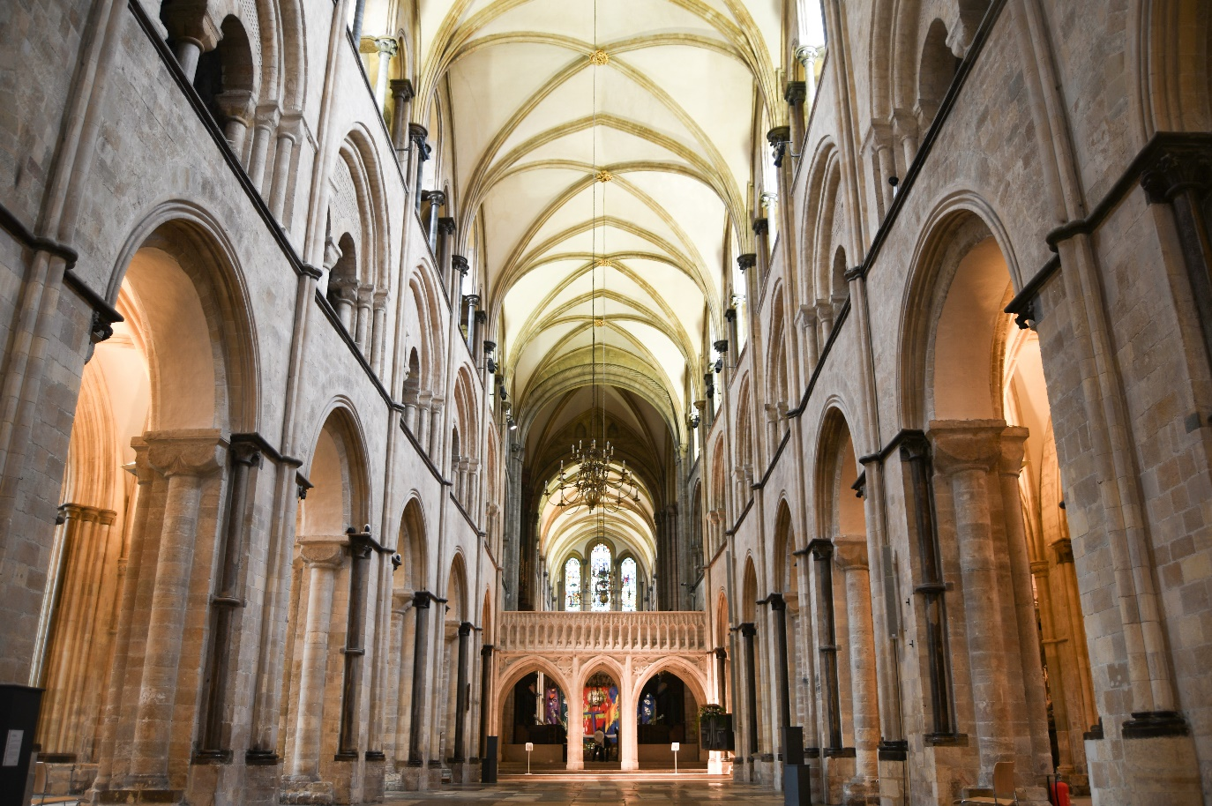
The Cathedral is a living church that has been at the centre of life in Chichester for over nine centuries. We are a place of worship and mission, the Mother Church of the Diocese of Chichester (which covers East and West Sussex) and the seat of the Bishop of Chichester. We are supported by a committed worshipping congregation, a small but dedicated staff team and over 400 volunteers.  The Cathedral is a leading visitor attraction, a venue for artistic and cultural activity, and an all-round hub for the community, welcoming over 250,000 visitors each year. Music is a central element in the Cathedral’s life. The Choir, which offers eight sung services each week and contributes to the Cathedral’s outreach around the diocese, has a high reputation at national and international level. We also host many high-quality musical performances each year by choirs, orchestras and chamber groups. | The Cathedral presents a comprehensive events programme and has a trading subsidiary, Chichester Cathedral Enterprises Ltd (CCEL), offering hospitality and retail services that support the Cathedral in delivering its mission. We have both a residential and commercial property portfolio many of them listed, in the Cathedral Close and beyond.  The Cathedral does not receive statutory or Church of England funding and is self-supporting, relying on self-generated income, donations, and fundraising activities. The Chapter is supported by the Chichester Cathedral Restoration & Development Trust and the Friends of Chichester Cathedral.  Further information about Chichester Cathedral can be found on the Cathedral website, including our Annual Report & Accounts.

Our Vision
The Cathedral’s anniversary in 2025 invited us to think more deeply about our purpose here in Chichester – in our worship, in our teaching, in our common life, in our commitment to diversity and inclusion and in our mission.
Invoking the prayers of St Richard, we have been drawn to that vein of spiritual renewal that animated the Latin West and especially this diocese in the thirteenth century – that is, the spirituality of St Dominic, which formed Richard and which shaped his own ministry here in Sussex, not least in resourcing his own pastoral care, teaching ministry, and expansion of the Cathedral’s life.
We’ve therefore taken inspiration from Dominican life in the so-called ‘Four Pillars’: Prayer, Study, Community and Mission. In these we begin to see a pattern of common life that helps us to fix our eyes on Christ as a means to becoming more prayerful; wiser in our understanding of what it means to be Christlike in the 2020s; becoming a community that is compassionate and joyful; and becoming more courageous in our mission and service to the world.
We hope you find inspiration and challenge in this pattern of life that we are setting before the Cathedral community and ask for your prayers as we seek to build up the household of faith here.

Prayer  Committing ourselves to seeking the face of God afresh in contemplation and worship, we hope to be guided by The Spirit to enter more deeply into the mystery of Jesus Christ and to radiate His beauty. | Study  Rooted in prayer, we seek to discern what it means to be human in an age of technological, political, social and economic change – through study, teaching and engagement with the World.
Community  Shaped by the insights of prayer, contemplation and study, we seek to build up our community in love, compassion and hospitality – encouraging each other to step out in faith and hope. | Mission  As a discerning, prayerful and loving community, we seek to take the message of God’s grace into the World with imagination, beauty and confidence, radiant with the promise of salvation.

You can read our full Vision document on the Cathedral website.

Commitment to Safeguarding
In accordance with Church of England’s policy, Promoting a Safer Church and the House of Bishops’ Safeguarding Policy and Practice Guidance, Chichester Cathedral is committed to the safeguarding of children, young people, and vulnerable adults who may be at risk.
The Cathedral works in partnership with the Diocese of Chichester to ensure that we operate in accordance with best practice at all times.
The care and protection of children, young people and vulnerable adults are the responsibility of the whole Cathedral community, whether clergy, staff, volunteers, contractors or members of the congregations. Everyone who participates in the life of the Cathedral has a role to play in promoting a safe environment for all.
To learn more about Safeguarding at the Cathedral please see our website.

Commitment to Equality & Diversity
At Chichester Cathedral we are dedicated to encouraging a supportive and inclusive workplace culture amongst our employee and volunteer workforce. It is our aim to ensure that if you work here or apply to work here, on either a paid or voluntary basis you will have an equal opportunity. We are also committed to working towards an organisation workforce that is diverse and as representative of our wider community as it can be.
We respect and value each of our employees and volunteers and are committed to enabling you to be able to perform to the best of your abilities and to be your authentic self in the workplace.

About the Role

Come and be a part of 950 years of ministry

Chichester Cathedral is one of the most significant spiritual, educational, artistic and heritage destinations in the South East. A place of Christian worship and learning for nearly 950 years, we continue to remain open for everyone, welcoming approximately 250 000 visitors from all over the world each year.

This is an exciting time to be joining the Cathedral as we prepare to celebrate our 950th anniversary in 2025 and as we are seeing to establish our new Learning and Engagement Team.

The Cathedral was built to draw people into a relationship with God and tell the Christian story. We are looking for a charismatic and confident lead who can bring this story alive to children and young people of all ages and with families, helping their faith to grow and flourish.

Our prayer is that the Cathedral will also be a shared resource for youth ministry in the Diocese of Chichester, supporting the amazing work that youth workers and children and family officers are engaged in across Sussex. Working with Deanery and Diocesan partners in ways which help to support, nurture and celebrate the faith of young people and their families from the Cathedral in Chichester will be an important aspect of this role.

Our mission is also a ‘sending out’. Whether it is out in schools taking Christian-based assemblies or collective worship, or leading projects in partnership with the Creative Learning Officer to support the needs of young people who are not part of any faith group, this role is about putting faith into action.

The worship that we provide at the Cathedral for children, young people and their families is growing. This is an exciting moment to join the Cathedral team as we seek together to develop our offer and support children, young people and families as their faith deepens and as we bring young people into the centre of our life. The Children and Youth Ministry Coordinator will have a key part to play in this vital ministry.

We are seeking someone who can both be a facilitator and an enabler. Who enjoys bringing people together, being responsive to the needs here and across the Deanery and Diocese, spotting opportunities and providing creative resources to help young people and their families to grow in faith.

If you would like an informal conversation with the Canon Chancellor, Jack Dunn, who has particular responsibility for our ministry to children, young people and families please email: HR@chichestercathedral.org.uk

JOB DESCRIPTION

Job Title: | Children and Youth Ministry Co-ordinator
Team: | Children, Young People and Families
Location: | Royal Chantry Offices
Line Manager; | Chancellor
Contract type: | Permanent
Hours: | 0.6 FTE including two Sundays per month
Date of completion: | March 2024

1 | Job Purpose
 | To help to lead faith engagement with children, young people, their families and caregivers at the Cathedral working with churches in the Deanery and in the Diocese and other partners across the whole of the Cathedral’s life.
2 | Principal Accountabilities
- to develop the Cathedral’s offering in providing, at the Cathedral, a variety of activities, events and information materials to support visits and projects which engage children and young people and their families, especially those coming from areas of higher deprivation and from audiences who might not traditionally engage with the Cathedral in growing and nurturing Christian faith;
- supporting initiatives and projects across the Deanery and Diocese which engage children and young people and their families and which develop and nurture their Christian faith;
- to support effective Safeguarding across the entire life of the Cathedral;
- work with teachers, children and young people to understand their learning needs and commission, as appropriate, third parties, including graphic designers, illustrators and content producers, to provide digital materials to meet those needs;
- to develop effective relationships and work with the Diocesan Children and Youth Workers to support Diocesan and local churches’ children and youth workers as required;
- to facilitate partnerships which work with young people, who are not faith based, which meet local need through local schools and civic institutions such as Chichester Library;
- to help develop and support worship opportunities for children and young people their families and care givers in the Cathedral, including targeted teaching and preparation for Baptism, First Communion and Confirmation candidates;
- to assist the Canon with responsibility for Children, Families and Young People to be an advocate for the voice of children and young people and their families in existing Cathedral worship and visitor experience and across the whole life of the Cathedral;
- to help deliver outreach to schools taking Christian-based assemblies or collective worship working in support of the Creative Learning Officer and helping to facilitate and welcome school visits.

3 | Level of Responsibility
a | People  This role does not have any direct line management responsibilities but may be required to work with and direct volunteers.
b | Financial Management  Responsible for planning appropriate spend.
c | Other  Member of the Cathedral Programming Group
4 | Contacts
Canon with oversight for Children, Young People, Families and Caregivers;
Creative Learning Manager;
Visitor Experience Team;
Education volunteers;
Staff, parents, caregivers, and pupils of visiting schools
Diocesan staff, especially the Diocesan Children’s Officer and Youth Officer;
Local churches, church children and youth workers and youth work organisations and Deanery Youth and Children and Family Advocates and Officers.

5 | Special Requirements
All our employees are required to undertake mandatory training including CofE safeguarding training as appropriate.

The role also requires:
- a practising Christian and communicant member in the Church of England or other denomination in sympathy with the Anglican church;
- a successful DBS check before employment commences;
- commitment to regular Sunday working each month and occasional evening work.

6 | Qualifications, Skills and Experience
Qualifications
Educated to GNVQ level 4 or equivalent.

Skills
- a good working knowledge of safe working practices and safeguarding best practice;
- familiarity with churches and how they operate;
- the ability to work collaboratively and also independently for optimum results;
- proficient Microsoft user;
- ability to develop and effectively manage third party relationships, including freelance photographers and designers;
- ability to understand creative challenge and to be able to relay requirements to internal and external stakeholders, including the Communications team and freelancers;
- the ability to use a content management system (CMS) to upload information and resources to the Cathedral website;
- proactive, self-motivated, enthusiastic with the ability to use initiative when required;
- resilience, integrity and a sense of humour;
- a creative approach to work with the ability to think outside the box and beyond the obvious;
- excellent organisation skills with the ability to successfully juggle often conflicting priorities.

Experience
- previous experience of working with children and young people in a youth -focused or out of school settings;
- a willingness to undertake appropriate continuing professional development in understanding children and youth ministry in order to provide appropriate advice.

How to apply

You are required to complete an application form, available on our website: here

Please email your completed application to: Val Timlin, our Head of HR at:
hr@chichestercathedral.org.uk

- The closing date for applications is midnight on Monday 29 April 2024.
- Interviews will take place in Chichester week commencing 13 May 2024.

If you wish to have a discussion about this role with the Rev Canon Jack Dunn, please email: hr@chichestercathedral.org.uk

Any questions?
Head of HR, Val Timlin
val.timlin@chichestercathedral.org.uk

