

Dean’s PA

Recruitment Pack

June 2024

|  |  |
| --- | --- |
| **Team:** | Clergy  Governance |
| **Location:** | Chantry Offices  Chichester Cathedral |
| **Contract Type:** | Permanent  Part Time |
| **Hours:** | 20 hours per week  FTE 35 hours per week |
| **Annual Salary:** | Actual 15,080  FTE £26,390 |
|  |  |

**Any questions?**

**Head of HR, Val Timlin**

val.timlin@chichestercathedral.org.uk

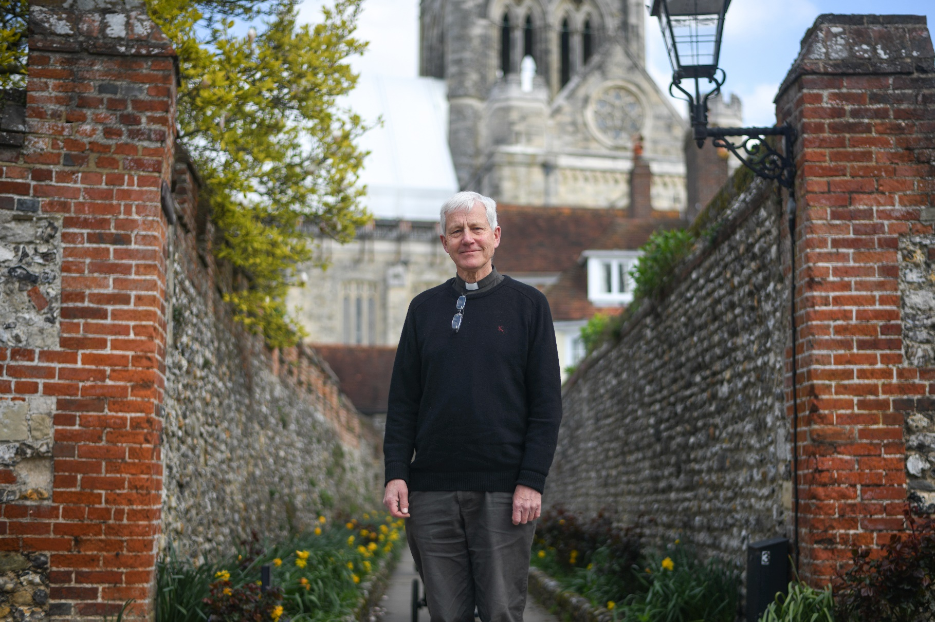

Welcome from the

Interim Dean of Chichester

Dear candidate,

Thank you for your interest in the post of Dean’s PA at Chichester Cathedral.

The Cathedral is right at the heart of the city of Chichester and attracts many visitors and tourists.  It has a rich liturgical tradition and a superb choir and hosts many cultural events.  It has a strong congregation, including a growing number of families, and a close relationship with the Prebendal School, where the Choristers are educated.  It also has a long history of engagement with the arts and supports a unique Workshop for Liturgical Art.

The Cathedral Chapter is seeking a part time Dean’s PA who will have responsibility for providing the Dean and other members of the Senior Leadership Team with administrative support. The Cathedral is at an exciting time in its history.

In September, it will welcome a new Dean and in 2025 it will celebrate its 950th history.  It’s a time for new beginnings.

**The Reverend Canon Simon Holland**

Interim Dean of Chichester

About Chichester Cathedral

|  |  |
| --- | --- |
|  | |
| The Cathedral is a living church that has been at the centre of life in Chichester for over nine centuries. We are a place of worship and mission, the Mother Church of the Diocese of Chichester (which covers East and West Sussex) and the seat of the Bishop of Chichester. We are supported by a committed worshipping congregation, a small but dedicated staff team and over 400 volunteers.  The Cathedral is a leading visitor attraction, a venue for artistic and cultural activity, and an all-round hub for the community, welcoming over 250,000 visitors each year. Music is a central element in the Cathedral’s life. The Choir, which offers eight sung services each week and contributes to the Cathedral’s outreach around the diocese, has a high reputation at national and international level. We also host many high-quality musical performances each year by choirs, orchestras and chamber groups. | The Cathedral presents a comprehensive events programme and has a trading subsidiary, Chichester Cathedral Enterprises Ltd (CCEL), offering hospitality and retail services that support the Cathedral in delivering its mission. We have both a residential and commercial property portfolio many of them listed, in the Cathedral Close and beyond.  The Cathedral does not receive statutory or Church of England funding and is self-supporting, relying on self-generated income, donations, and fundraising activities. The Chapter is supported by the Chichester Cathedral Restoration & Development Trust and the Friends of Chichester Cathedral.  Further information about Chichester Cathedral can be found on the Cathedral website, including our [Annual Report & Accounts](https://www.chichestercathedral.org.uk/about-us/reports). |

Our Vision

The Cathedral’s anniversary in 2025 invited us to think more deeply about our purpose here in Chichester – in our worship, in our teaching, in our common life, in our commitment to diversity and inclusion and in our mission.

Invoking the prayers of St Richard, we have been drawn to that vein of spiritual renewal that animated the Latin West and especially this diocese in the thirteenth century – that is, the spirituality of St Dominic, which formed Richard and which shaped his own ministry here in Sussex, not least in resourcing his own pastoral care, teaching ministry, and expansion of the Cathedral’s life.

We’ve therefore taken inspiration from Dominican life in the so-called ‘Four Pillars’: Prayer, Study, Community and Mission. In these we begin to see a pattern of common life that helps us to fix our eyes on Christ as a means to becoming more prayerful; wiser in our understanding of what it means to be Christlike in the 2020s; becoming a community that is compassionate and joyful; and becoming more courageous in our mission and service to the world.

We hope you find inspiration and challenge in this pattern of life that we are setting before the Cathedral community and ask for your prayers as we seek to build up the household of faith here.

|  |  |
| --- | --- |
| **Prayer**  Committing ourselves to seeking the face of God afresh in contemplation and worship, we hope to be guided by The Spirit to enter more deeply into the mystery of Jesus Christ and to radiate His beauty. | **Study**  Rooted in prayer, we seek to discern what it means to be human in an age of technological, political, social and economic change – through study, teaching and engagement with the World. |
| **Community**  Shaped by the insights of prayer, contemplation and study, we seek to build up our community in love, compassion and hospitality – encouraging each other to step out in faith and hope. | **Mission**  As a discerning, prayerful and loving community, we seek to take the message of God’s grace into the World with imagination, beauty and confidence, radiant with the promise of salvation. |

You can read our full [Vision](https://www.chichestercathedral.org.uk/vision) document on the Cathedral website.

Commitment to Safeguarding

In accordance with Church of England’s policy, *Promoting a Safer Church* and the House of Bishops’ *Safeguarding Policy and Practice Guidance*, Chichester Cathedral is committed to the safeguarding of children, young people, and vulnerable adults who may be at risk.

The Cathedral works in partnership with the Diocese of Chichester to ensure that we operate in accordance with best practice at all times.

The care and protection of children, young people and vulnerable adults are the responsibility of the whole Cathedral community, whether clergy, staff, volunteers, contractors or members of the congregations. Everyone who participates in the life of the Cathedral has a role to play in promoting a safe environment for all.

To learn more about Safeguarding at the Cathedral [please see our website.](https://www.chichestercathedral.org.uk/safeguarding)

Commitment to Equality & Diversity

At Chichester Cathedral we are dedicated to encouraging a supportive and inclusive workplace culture amongst our employee and volunteer workforce.   It is our aim to ensure that if you work here or apply to work here, on either a paid or voluntary basis you will have an equal opportunity.  We are also committed to working towards an organisation workforce that is diverse and as representative of our wider community as it can be.

We respect and value each of our employees and volunteers and are committed to enabling you to be able to perform to the best of your abilities and to be your authentic self in the workplace.

About the Role

We have an exciting opportunity for a part time PA to provide administrative support our senior leadership team comprising the Dean of Chichester, who is the Cathedral’s CEO, three Residentiary Canons and our Communar, who the Cathedral’s lay Chief operating Officer.

We are looking for someone who is organised and able to juggle conflicting priorities and able to work well in a team. Further details are available in the job description below.

It’s a part time role, ideally worked across 5 mornings a week but we are flexible.

We offer the usual benefits like a slightly enhanced pension contribution, 34 days’ leave including Bank Holidays, Employee Assistance Programme, free onsite parking, discounts in the Café and Cathedral shop, employer supported volunteering and flexible working opportunities.

If you want to apply, it’s simple, please:

1. go to our website [vacancies page](https://www.chichestercathedral.org.uk/about-us/our-team/job-vacancies)
2. complete an application form and submit it to Val Timlin, our Head of HR, at: [hr@chichestercathedral.org.uk](mailto:hr@chichestercathedral.org.uk)
3. note the interview date which is Tuesday 6 August.

**Job Description**

|  |  |
| --- | --- |
| **Job Title:** | Dean’s PA |
| **Team:** | Communar’s Office |
| **Location:** | Cathedral Offices |
| **Line Manager:** | Chapter Clerk |
| **Matrix reporting line:** | The Dean and Senior Leadership Team |
| **Contract type:** | Permanent |
| **Hours:** | 20 hours per week ideally worked over 5 mornings |
| **Date of completion:** | June 2024 |

|  |  |
| --- | --- |
| **1** | **Job Purpose** |
|  | To provide administrative support to the Dean of Chichester, who is the Cathedral’s CEO, and other members of the Senior Leadership Team, comprising the three Residentiary Canons and the Communar, who is the Cathedral’s Chief Operating Officer. |
| **2** | **Principal Accountabilities** |
|  | **Supporting the Dean of Chichester:**  To provide general administrative support for the Dean, including:   * + diary and inbox management   + organising in-person and online events/meetings   + Sending invitations, monitoring attendance, booking venues, catering, travel plans etc   + drafting rotas, correspondence, communications etc   + managing sensitive and confidential information   + recording-keeping, filing   + reminding the Dean of upcoming deadlines, committees etc   + acting as first point of contact with key external relationships   + and any other duties as directed   **Supporting the Senior Leadership Team:**  To provide general administrative support, in support of SLT members’ remits and priorities. For example, this might mean administrative support for a specific project led by one of the Canons, in addition to general PA-type duties.  **Supporting the Cathedral:** As with all our staff, we ask that the post holder be alert to any issues that may impact on the Safeguarding or Health & Safety of our community and to adhere to and support all relevant protocols and procedures. |
| **3** | **Level of Responsibility** |
| **a** | **People**  The post holder does not have direct management responsibilities |
| **b** | **Financial Management**  The post holder does not have any budgetary responsibility |
| **4** | **Contacts** |
|  | Working internally with colleagues including employees, clergy, volunteers and the wider Cathedral congregation.  Working externally with contacts from across the city, diocese and county; occasional work with members of the wider Church (other Cathedrals and the National Church Team). |
| **5** | **Special Requirements** |
|  | * Chichester Cathedral is a living church and applicants should be in sympathy with our Christian mission. * The ability to maintain confidentiality, is imperative. * All our employees are required to undertake mandatory training including appropriate CofE safeguarding training; * The post holder will work primarily from the Cathedral offices in Chichester though there may be scope to work remotely on occasions, by agreement. * There may be occasional out-of-hours working. |
| **6** | **Qualifications, Skills and Experience** |
|  | **Qualifications**  GNVQ level 3 or equivalent  **Skills**   * excellent interpersonal skills; * ability to manage competing priorities and deadlines; * excellent Microsoft Office user; * strong organisation skills; * good team player.   **Experience**   * previous administrative experience, preferably in a PA role, is essential; * experience of working in a church or cathedral setting and an understanding of the Church of England’s services and structures would be an advantage; * using a CRM database would be desirable. |

How to apply

If you want to apply, it’s simple, please:

* go to our website [vacancies page](https://www.chichestercathedral.org.uk/about-us/our-team/job-vacancies)
* complete an application form and submit it to Val Timlin, our Head of HR, at: [**hr@chichestercathedral.org.u**k](mailto:hr@chichestercathedral.org.uk) by the **closing date** **midnight on 6 August 2024**
* note the interview date which is **Tuesday 6 August 2024.**

If you wish to have a discussion about this role with Charlotte Rattray, Chapter Co-ordinator and line manager for this post, please email her at:

[**charlotte.rattray@chichestercathedral.org.uk**](mailto:charlotte.rattray@chichestercathedral.org.uk)

**Any questions?**

**Head of HR, Val Timlin**

val.timlin@chichestercathedral.org.uk

