**Marketing**

**Co-ordinator** (Content)

RECRUITMENT PACK

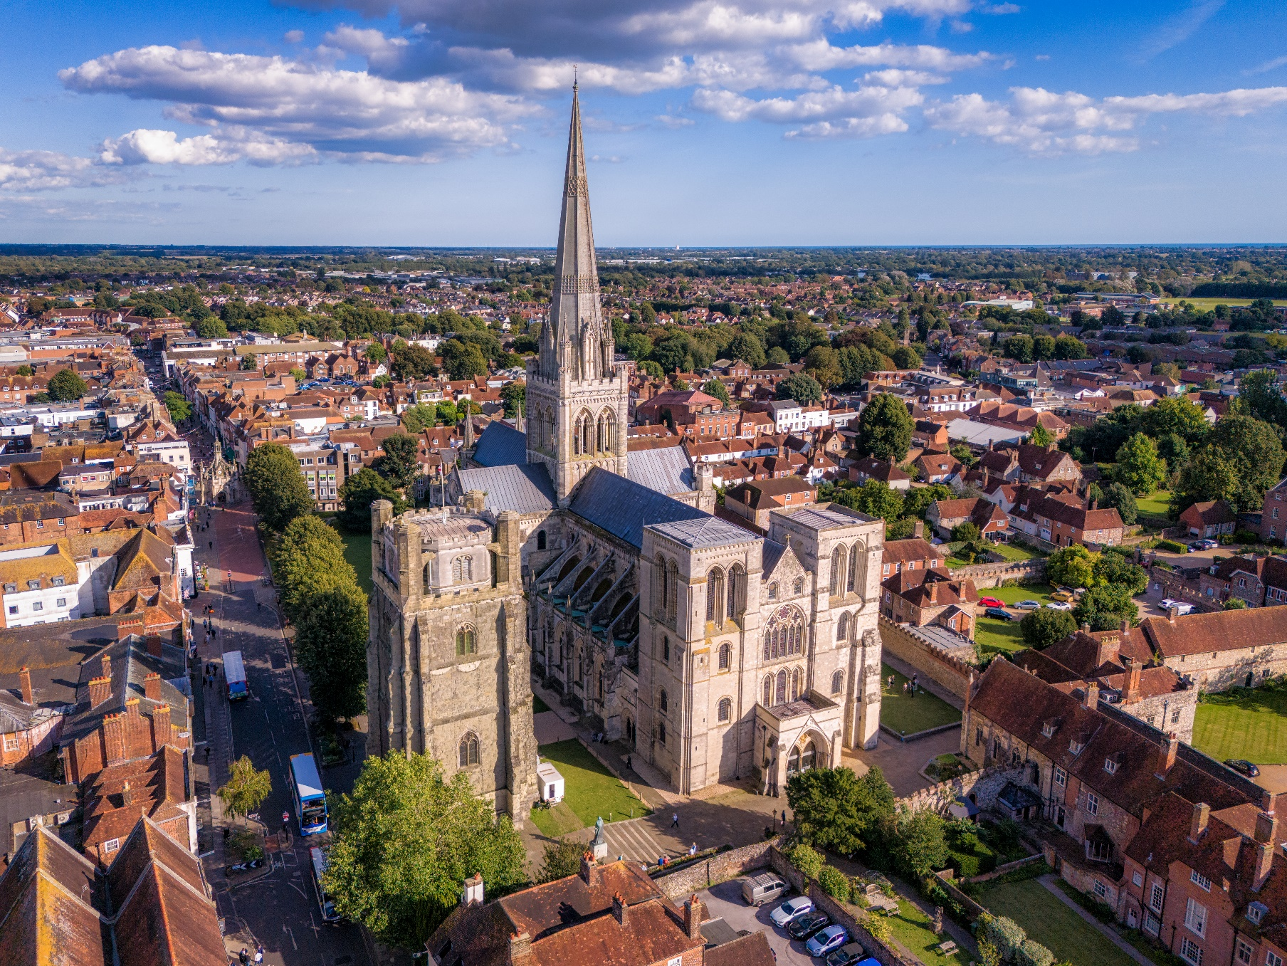

**Welcome from**

**the Dean**

Thank you for your interest in joining the team here at Chichester Cathedral.

As we look ahead to the next chapter in the Cathedral’s story, following the successful conclusion of our 950th anniversary celebrations, this is an exciting moment to join us. Building on this momentum, you’ll play a key role in shaping how we communicate the life, work and witness of this extraordinary place - reaching local communities, visitors, supporters and pilgrims alike.

Chichester Cathedral stands at the heart of a beautiful and historic city, close to the South Downs and the Sussex coast. With a rich heritage and a vibrant, outward-facing ministry, it offers a unique and rewarding working environment grounded in faith, creativity and collaboration.

If you feel your skills and experience align with our vision, we would be delighted to hear from you. You’ll find all the key details within this Recruitment Pack, and we warmly welcome informal enquiries should you wish to find out more.

The Very Reverend Dr Edward Dowler

**Dean of Chichester**

About Chichester Cathedral

|  |  |
| --- | --- |
|  | |
| The Cathedral is a living church that has been at the centre of life in Chichester for over nine centuries. We are a place of worship and mission, the Mother Church of the Diocese of Chichester (which covers East and West Sussex) and the seat of the Bishop of Chichester. We are supported by a committed worshipping congregation, a small but dedicated staff team and over 400 volunteers.  The Cathedral is a leading visitor attraction, a venue for artistic and cultural activity, and an all-round hub for the community, welcoming over 250,000 visitors each year. Music is a central element in the Cathedral’s life. The Choir, which offers eight sung services each week and contributes to the Cathedral’s outreach around the diocese, has a high reputation at national and international level. We also host many high-quality musical performances each year by choirs, orchestras and chamber groups. | The Cathedral presents a comprehensive events programme and has a trading subsidiary, Chichester Cathedral Enterprises Ltd (CCEL), offering hospitality and retail services that support the Cathedral in delivering its mission. We have both a residential and commercial property portfolio many of them listed, in the Cathedral Close and beyond.  The Cathedral does not receive statutory or Church of England funding and is self-supporting, relying on self-generated income, donations, and fundraising activities. The Chapter is supported by the Chichester Cathedral Restoration & Development Trust and the Friends of Chichester Cathedral.  Further information about Chichester Cathedral can be found on the Cathedral website, including our [Annual Report & Accounts](https://www.chichestercathedral.org.uk/about-us/reports). |

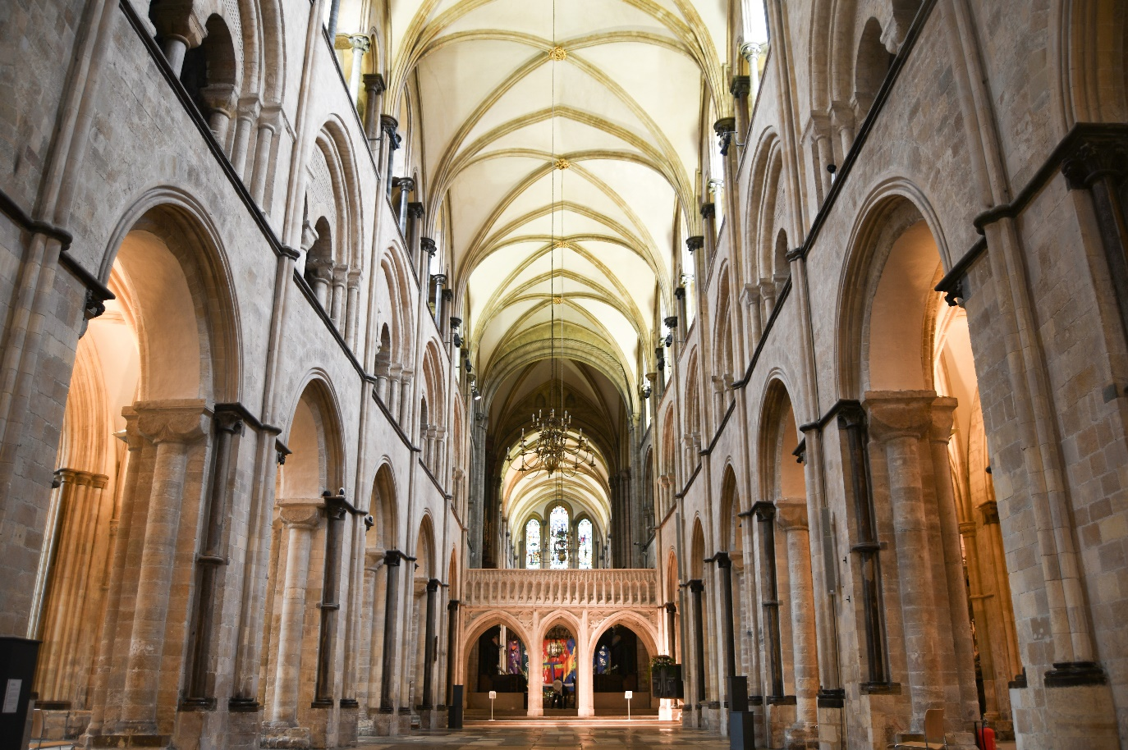

Our vision

As we journey through our **950th anniversary in 2025**, we've been reflecting on what really matters to us here at Chichester Cathedral. We’ve drawn inspiration from the **Dominican tradition** - focusing on **prayer**, **learning**, **community**, and **mission**. It's all about growing together in faith, wisdom, and compassion, and finding new ways to serve and connect with the world around us. Whether it's through worship, learning, or supporting each other, we aim to be a community that’s welcoming, joyful, and ready to make a difference.

You can read our full [Vision](https://www.chichestercathedral.org.uk/vision) document on the Cathedral website.

Our values

Our team came together to create values that we live by every day - **Teamwork**, **Inclusivity**, **Communication**, and **Kindness (TICK)**. These aren't just words to us; they guide how we work, support one another, and interact with the world around us.

* **Teamwork**: We believe we’re stronger together, collaborating across departments and projects to achieve shared goals.
* **Inclusivity**: Everyone’s voice matters. We embrace diversity and strive to create a welcoming space where everyone feels valued and included.
* **Communication**: Clear, open communication is key to everything we do - whether sharing ideas, solving problems, or supporting each other.
* **Kindness**: We treat each other with respect and empathy, always looking out for one another and creating a positive, caring work environment.

Our commitment to our team

At Chichester Cathedral, we’re committed to living our values every day. We stay connected through regular **newsletters**, **events**, and **socials**, making sure everyone feels part of the team.

We listen to and encourage open discussions through **one-to-one meetings** and our **Employee Forum**, giving everyone a chance to share their ideas.

We support your professional growth with **training** and **development opportunities** to help you succeed in your role.

Inclusivity is key, with access to **Disability Awareness Training**, **Racial Justice resources**, and safeguarding (see Page 11), ensuring a welcoming environment for all.

We’re dedicated to creating a supportive workplace where every team member feels valued and heard.

JOB DESCRIPTION

|  |  |
| --- | --- |
| **JOB TITLE:** | Marketing Co-ordinator (Content) |
| **TEAM:** | Marketing & Visitor Experience |
| **LOCATION:** | Royal Chantry Offices (located within the Cathedral Cloisters, PO19 1PX); Hybrid working arrangements available |
| **LINE MANAGER:** | Head of Marketing & Communications |
| **MATRIX REPORTING:** | Chief Operating Officer (Communar) |
| **CONTRACT TYPE:** | Fixed term (22 months) |
| **HOURS:** | Part-time, 0.5 FTE (17.5 hours per week) |
| **SALARY:** | £13,636 per annum (pro rata for 17.5 hours per week), equivalent to £27,273 full-time (FTE) |
| **DATE OF COMPLETION:** | September 2025 – July/August 2027 |

**IMAGE: Peter Walker’s *Peace Doves*, Chichester Cathedral (2023)**

|  |  |
| --- | --- |
| **1** | **JOB PURPOSE** |
|  | This is a brand-new role in our expanding Marketing & Visitor Experience team - a unique opportunity to grow your creative communications career in a setting steeped in history and alive with activity.  As Marketing Co-ordinator (Content & Social Media), you’ll be a key part of our storytelling engine - shaping and sharing engaging, multi-format content that celebrates everything from ancient architecture and world-class music to learning programmes, services and special events. From short-form video and photo galleries to insightful articles and print materials, your work will help connect our audiences more deeply to the Cathedral’s mission and life.  Working closely with the Head of Marketing & Communications and colleagues across the Cathedral’s life, including dedicated volunteers, you’ll plan and deliver content that builds brand awareness, strengthens engagement, and supports visitor growth, charitable giving and community outreach.  This is an exciting, purposeful opportunity for a creative communicator with a strong eye for design, tone and storytelling - and a passion for making culture and heritage accessible to all. |
| **2** | **PRINCIPAL ACCOUNTABILITIES** |
|  | * Work with the Head of Marketing & Communications to **implement marketing and communications plans,** with a focus on **storytelling** and **multi-channel content delivery**. * Contribute to the development of campaigns that **promote the Cathedral’s programme to priority audiences**, including worshippers, visitors, members, and donors. * Create, curate, and schedule high-quality digital content **- including video, photography, and copy - for social media, website, email and print**, ensuring all assets are consistent with the Cathedral’s brand and tone of voice. * Plan and **produce compelling copy for a range of channels** (including web, email, press releases, blog posts and social media captions), adapting tone and style to suit different platforms and audiences. * **Collaborate with teams** including Music, Learning, Fundraising and Visitors to shape content that supports their objectives and contributes to cross-departmental priorities. * Provide support during periods of annual leave or key meetings by **representing the Head of** **Marketing** when appropriate. * Assist with **monitoring and reporting on content performance**, contributing to campaign evaluations, monthly digital dashboards, and internal communications round-ups. * **Use data insights to inform ongoing content development** and audience engagement strategies. |
| **3** | **LEVEL OF RESPONSIBILITY** |
| **a** | **People**  No direct line reports. |
| **b** | **Financial Management**  Supporting the Head of Marketing & Communications in oversight of project and campaign budgets. |
| **c** | **Other**  N/A |
| **4** | **CONTACTS** |
|  | **Internal**   * Work closely with lay and ordained colleagues to understand and support their marketing, communications and content needs, ensuring they are able to contribute effectively to campaigns and digital projects. * Collaborate with internal teams to deliver audience development initiatives, ensuring that campaigns reach and engage key visitor and congregation segments. * Play a supporting role in internal communications, helping to deliver clear and effective messaging to staff, volunteers, and the wider Cathedral community.   **External**   * Support third-party partnerships to develop marketing and audience engagement strategies that enhance the Cathedral’s profile as a visitor attraction. * Engage with agencies, freelancers, and other specialists to commission content or services as needed, ensuring high quality and value for money. * Collaborate with other cathedrals, churches and visitor attractions to share best practices and identify collaborative opportunities. |
| **5** | **SPECIAL REQUIREMENTS** |
|  | * The role may require occasional evening and weekend work, with flexibility during peak periods. * Mandatory safeguarding and GDPR training will be provided. * Recognition of the Cathedral’s Christian mission, with comfort in promoting its role as a living church, is essential. |
| 6 | **QUALIFICATIONS, SKILLS AND EXPERIENCE**  (ESSENTIAL UNLESS SPECIFIED OTHERWISE; D - DESIRABLE) |
|  | * Experience in content creation and digital communications, preferably in a cultural, charitable or heritage context. * Strong copywriting and proofreading skills, with a clear and engaging style. * Familiarity with major social media platforms and scheduling tools (e.g. Meta Business Suite). * Basic video editing and design skills (e.g. Canva, Adobe Express or equivalent). * Experience using a CMS to update web content (WordPress, Drupal or similar). * Ability to use analytics tools to inform content planning and optimisation. * A collaborative team player with good organisational and time-management skills * Knowledge of the UK’s cultural and visitor landscape is desirable. |

What could my day-to-day look like?

Every day at Chichester Cathedral is different, with each season bringing new services, events, exhibitions and more. This is what a standard day could look like:

|  |
| --- |
| **Morning:** Content creation, planning and scheduling |
| Creating engaging posts for social media platforms (Instagram, Facebook, TikTok, X), promoting the Cathedral’s events, services and campaigns, tailoring them to each platform’s audience, and review previous content performance to refine strategies. |
| **Late Morning:** Campaign coordination and planning |
| Meet with the Head of Marketing & Communications and Cathedral teams (Music, Visitors, Learning) to discuss upcoming events and projects. You might do this by attending one of our weekly Diary Meetings. Collaborate on content that supports the Cathedral’s mission and aligns with the broader marketing plan. |
| **Afternoon:** Website updates and Email preparation |
| Update the Cathedral’s website by adding new events and refreshing content. Draft and design an email to subscribers updating them about these new events. |
| Late Afternoon: Data management and reporting |
| Monitor the data coming in from your emailing, and ensure it’s captured in our CRM. Analyse the data to track growth and identify improvement areas. |
| **End of Day**: Event Planning and internal communications |
| Check in on messages, comments and reactions on social media before setting your out of office. |
| **Ad Hoc tasks** |
| Be ready to assist with unplanned tasks, whether it’s helping coordinate a special blog, handling visitor inquiries or designing an asset needed for an event on the Cathedral floor |

What projects might I be working on?

**CHICHESTER950 LIGHT SHOW**

Assist in the marketing and promotion of the 950 Light Show – an immersive Son et Lumiere event bring our 950th anniversary celebrations to a close in Autumn 2025.

Develop engaging digital content for the Cathedral’s website and social media, work on PR initiatives and coordinate with the artist and production teams. You’ll also help promote the creation of the show, behind-the-scenes content and interactive online experiences to enhance audience engagement, with a focus on drawing in local residents, families and tourists.

**SUSTAINABILITY**

We are committed to becoming carbon neutral and recognise the Christian duty to care for God’s creation. We are dedicated to working with others to share knowledge and follow the Church of England’s Routemap to achieve net zero carbon by 2030.

Twice a year, you will have the opportunity to deliver communications campaigns which shares our commitment to sustainability, and promotes our initiatives, including Clothing Swap Shops, environmental surveys and Fairtrade Coffee Mornings (to name a few!).

**ASHES TO FIRE**

*ASHES TO FIRE*will be a compelling exhibition by British artist Alice Carter. The series, comprising seven large-scale oil paintings, journeying from Ash Wednesday to Pentecost, will be on display in the Cathedral’s South Transept from 13 February — 5 April 2026.

You’ll have the opportunity to work with Alice to spread the word of this new body of work, which she hopes will “give people a chance to pause and feel connected to something bigger than themselves.”

Commitment to Safeguarding

In accordance with Church of England’s policy, *Promoting a Safer Church* and the House of Bishops’ *Safeguarding Policy and Practice Guidance*, Chichester Cathedral is committed to the safeguarding of children, young people, and vulnerable adults who may be at risk.

The Cathedral works in partnership with the Diocese of Chichester to ensure that we operate in accordance with best practice at all times.

The care and protection of children, young people and vulnerable adults are the responsibility of the whole Cathedral community, whether clergy, staff, volunteers, contractors or members of the congregations. Everyone who participates in the life of the Cathedral has a role to play in promoting a safe environment for all.

To learn more about Safeguarding at the Cathedral [please see our website.](https://www.chichestercathedral.org.uk/safeguarding)

Commitment to Equality & Diversity

At Chichester Cathedral we are dedicated to encouraging a supportive and inclusive workplace culture amongst our employee and volunteer workforce.   It is our aim to ensure that if you work here or apply to work here, on either a paid or voluntary basis you will have an equal opportunity.  We are also committed to working towards an organisation workforce that is diverse and as representative of our wider community as it can be.

We respect and value each of our employees and volunteers and are committed to enabling you to be able to perform to the best of your abilities and to be your authentic self in the workplace.

How to apply

You are asked to complete an application form, available on our website. [**Click on this link to access the form >>**](https://www.chichestercathedral.org.uk/about-us/job-vacancies/part-time-marketing-co-ordinator-content)

Once completed, please email your completed application to: Val Timlin, our Head of HR at:

[**hr@chichestercathedral.org.uk**](mailto:hr@chichestercathedral.org.uk)

**KEY DATES**

* The closing date for applications is **12.00am (midnight) on 17th August 2025.**
* Interviews will take place in person in Chichester, or via Microsoft Teams, **26th August 2025.**

If you wish to have a discussion about this role please email: [**hr@chichestercathedral.org.uk**](mailto:hr@chichestercathedral.org.uk)