

Lay Vicar

**Recruitment Pack**

September 2025

|  |  |
| --- | --- |
| **Team:** | **Liturgy & Music** |
| **Contract Type:** | **Permanent** |
| **Hours:** | **Part time** |
| **Salary:** | **£11,446 plus £7,731 housing allowance** |
| **Location** | **Chichester** |

**Any questions?**

**Head of HR, Val Timlin**

val.timlin@chichestercathedral.org.uk

**About Chichester Cathedral**

|  |  |
| --- | --- |
|  | |
| The Cathedral is a living church that has been at the centre of life in Chichester for over nine centuries. We are a place of worship and mission, the Mother Church of the Diocese of Chichester (which covers East and West Sussex) and the seat of the Bishop of Chichester. We are supported by a committed worshipping congregation, a small but dedicated staff team and over 400 volunteers.  The Cathedral is a leading visitor attraction, a venue for artistic and cultural activity, and an all-round hub for the community, welcoming over 250,000 visitors each year. Music is a central element in the Cathedral’s life. The choir, which offers eight sung services each week and contributes to the Cathedral’s outreach around the diocese, has a high reputation at national and international level. We also host many high-quality musical performances each year by choirs, orchestras and chamber groups. | The Cathedral presents a comprehensive events programme and has a trading subsidiary, Chichester Cathedral Enterprises Ltd (CCEL), offering hospitality and retail services that support the Cathedral in delivering its mission. We have both a residential and commercial property portfolio many of them listed, in the Cathedral Close and beyond.  The Cathedral does not receive statutory or Church of England funding and is self-supporting, relying on self-generated income, donations, and fundraising activities. The Chapter is supported by the Chichester Cathedral Restoration & Development Trust and the Friends of Chichester Cathedral.  Further information about Chichester Cathedral can be found on the Cathedral website, including our [Annual Report & Accounts](https://www.chichestercathedral.org.uk/about-us/reports). |

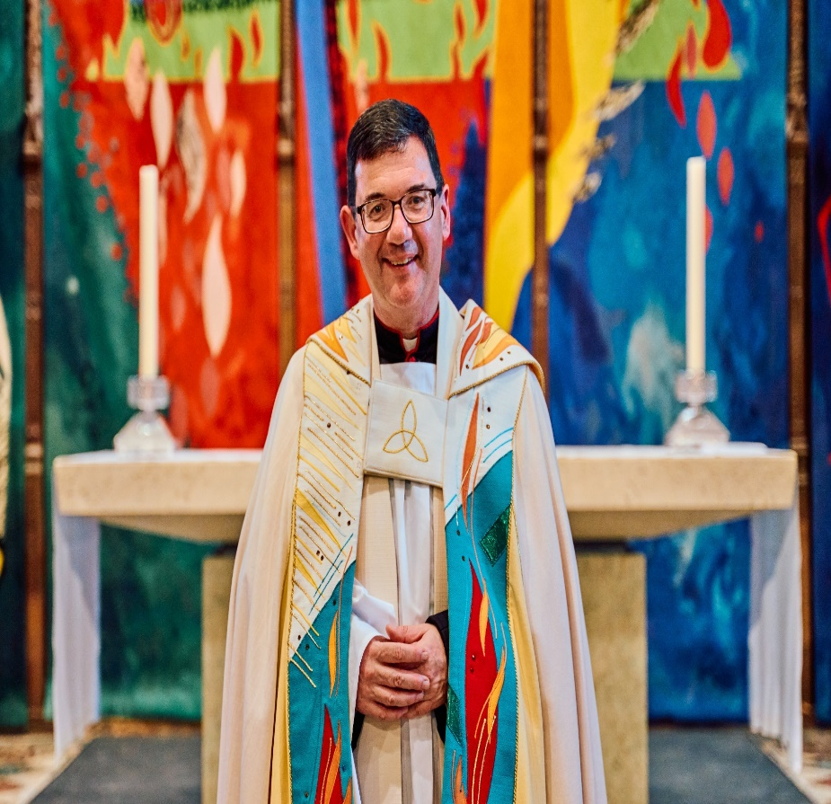**Welcome from the Dean**

Thank you for your interest in the post of Lay Vicar at Chichester Cathedral.  We seek a highly gifted singer to help us sustain – and enhance – our excellent musical tradition.

The Cathedral is at the heart of the city of Chichester, and attracts many visitors and tourists.  We have a rich liturgical tradition, supported by our world-class choir, and enjoy a close relationship with the Prebendal School, where the choristers are educated.  Our strong regular congregation, drawn from the city and surrounding areas, includes a growing number of families.  The Cathedral also has a long history of engagement with the arts, and hosts many cultural events

The Cathedral Chapter is seeking a Lay Vicar who will sing at the many choral services that are offered each year.  These include Evensong six days per week during term time, a full schedule of Sunday services, and a variety of special services, broadcasts and public performances through the year.  Further details are in the job description below.

As a relatively small choir and Cathedral, there is a strong sense of belonging, with an ethos of mutual care and respect between choir, clergy, Cathedral staff and congregation.

**Very Reverend Dr Edward Dowler**

Dean of Chichester Cathedral

**Welcome from the Communar**

Thank you for your interest in our vacancy for a Lay Vicar at Chichester Cathedral.

This is an exciting time to join our small, dedicated team as we look to the future with ambition and purpose.  Every member of our team plays a vital role in preserving our extraordinary heritage while helping us to thrive in a rapidly changing world.

The Cathedral stands at the heart of the city – a place of worship, history, creativity, and community.  We have a long and excellent music tradition and you will be joining an established and well-regarded choir under the leadership of our Master of Choristers, Charles Harrison.

You will be joining a committed and collaborative team, where your talents will have real impact.  If you meet our skills criteria, outlined in the job description below, we’d love to hear from you.

**Amy Sim**

Chief Operating Officer & Communar

|  |  |
| --- | --- |
|  | |
|  |  |

**Commitment to Safeguarding**

In accordance with Church of England’s policy, *Promoting a Safer Church* and the House of Bishops’ *Safeguarding Policy and Practice Guidance*, Chichester Cathedral is committed to the safeguarding of children, young people, and vulnerable adults who may be at risk.

The Cathedral works in partnership with the Diocese of Chichester to ensure that we operate in accordance with best practice at all times.

The care and protection of children, young people and vulnerable adults are the responsibility of the whole Cathedral community, whether clergy, staff, volunteers, contractors or members of the congregations. Everyone who participates in the life of the Cathedral has a role to play in promoting a safe environment for all.

To learn more about Safeguarding at the Cathedral [please see our website.](https://www.chichestercathedral.org.uk/safeguarding)

**Commitment to Equality & Diversity**

At Chichester Cathedral we are dedicated to encouraging a supportive and inclusive workplace culture amongst our employee and volunteer workforce.   It is our aim to ensure that if you work here or apply to work here, on either a paid or voluntary basis you will have an equal opportunity.  We are also committed to working towards an organisation workforce that is diverse and as representative of our wider community as it can be.

We respect and value each of our employees and volunteers and are committed to enabling you to be able to perform to the best of your abilities and to be your authentic self in the workplace.

**The Job Description**

|  |  |
| --- | --- |
| **Job Title:** | Lay Vicar |
| **Team:** | Liturgy & Music |
| **Location:** | Cathedral |
| **Line Manager;** | Organist and Master of the Choristers |
| **Matrix reporting line:** | Precentor |
| **Contract type:** | Permanent |
| **Hours:** | Part time |
| **Date of completion:** | August 2025 |

|  |  |  |  |
| --- | --- | --- | --- |
| **1** | **Job Purpose** | | |
|  | The primary duty of the Lay Vicars is to attend rehearsals and sing daily services in the Cathedral, aspiring to the highest standards of performance and conduct. | | |
| **2** | **Principal Accountabilities** | | |
|  | Lay Vicars are required to attend and sing at the regular schedule of choral services, as follows: | | |
| **Day** | **Rehearsal** | **Service** |
| **Monday** | 16:50 tenors and basses arrive 17:00 | 17:30 Lower Voices Evensong |
| **Tuesday** | 17:00 | 17:30 Evensong |
| **Wednesday** | No service for Cathedral Choir - Evensong sung by visiting choirs | |
| **Thursday** | 17:00 | 17:30 Evensong |
| **Friday** | 17:00  18:15–19:15 Full-choir rehearsal | 17:30 Evensong |
| **Saturday** | 17:00 | 17:30 Evensong |
| **Sunday** | 9:25  14:30 | 10:00 Matins  11:00 Eucharist  15:00 Evensong |
|  | Separate schedules are followed during Holy Week and the Christmas period.  On certain major festivals a Eucharist at 1730 replaces Choral Evensong.  If the Choir sings on a Wednesday, another non-singing day is substituted.  Up to 4 regular services (including the 11am Sunday Eucharist) are livestreamed online via the Cathedral’s website, Facebook and YouTube pages, and remain available for a period of up to 48 hours. Additional livestreams or prolonged online availability are agreed in advance, and remunerated with the standard special service fee.  Lay Vicars are also required to:   * attend and sing at services, broadcasts or public performances outside the regular schedule, such as may reasonably be required from time to time by the Chapter; * participate, up to three times a year, in services at a parish church (as part of the Cathedral’s mission to its diocese), in lieu of a regular Cathedral service, and for which travel expenses will be reimbursed; * perform in up to two fundraising events per annum for which reasonable time off in lieu will be provided; * participate in the annual Southern Cathedrals Festival, which alternates between Chichester, Salisbury and Winchester Cathedrals each year, as well as tours and recordings, for which additional fees are paid; * make effective use of limited rehearsal time by arriving punctually and having prepared repertoire to high standards of familiarity and accuracy, so that rehearsals can be devoted to musical detail; * demonstrate conduct in rehearsals and services that sets a calm and positive example to the choristers, and that will not distract members of the congregation; * contribute to the choir’s smart and professional presentation by observing reasonable dress code requirements; * maintain a high level of vocal performance and to participate in ongoing professional development. A substantial grant has been secured from the Cathedral Music Trust to support the cost of termly singing lessons. (As at August 2025, the tutor is Berty Rice.)   The Lay Vicar contract allows for not less than 100 days holiday per annum including at least 10 Sundays. Leave is taken during the choir school holidays. The high quality of the choir relies, in part, on the 6-person team of Lay Vicars being present for most services, but we recognise the value and importance of encouraging singers to develop other strands of their performing career, and making contacts outside Chichester; for a set number of absences, the cost of engaging deputies is met by the Chapter. There is a procedure for remunerating deputies, who are booked from a list approved by the Master of the Choristers. | | |
| **3** | **Level of Responsibility** | | |
|  | The post-holder does not have people management or financial management responsibilities. | | |
| **4** | **Contacts** | | |
|  | Lay Vicars have regular contact with members of the Choral Foundation which comprises:   * the Organist & Master of the Choristers who is line manager for Lay Vicars; * the Assistant Organist; * the Organ Scholar, who serves a one-year term; * other Lay vicars, of whom there are 6 in total.   There is more limited contact with 18 boy and girl choristers who board and are educated at the Prebendal School. | | |
| **5** | **Special Requirements** | | |
|  | All our employees are required to undertake mandatory training including CofE safeguarding training as appropriate.  Lay Vicars should be sympathetic to the liturgical life of the Cathedral, and preferably communicant members of the Church of England or regular communicants of their own church.  An enhanced DBS disclosure is a requirement for this appointment. | | |
| **6** | **Qualifications, Skills and Experience** | | |
|  | Lay Vicars are required to be:   * versatile singers with excellent aural and sight-singing skills; * at ease with solo singing and able to blend within the small ensemble; * familiar with liturgical repertoire and psalm-singing to Anglican chant; * able to work within a team which includes children. | | |

**How to apply**

You are required to complete an application form, available on our website: [**here**](https://www.chichestercathedral.org.uk/about-us/our-team/job-vacancies)

Please email your completed application to: Val Timlin, our Head of HR at:

[hr@chichestercathedral.org.uk](mailto:hr@chichestercathedral.org.uk)

* The closing date for applications is 9.00am on **Monday 29 September 2025**
* Interviews and auditions will take place in Chichester on **Monday 6 October 2025**

If you wish to have a discussion about this role with Charles Harrison, Organist & Master of the Choristers, please email XXX

