


Visual Merchandiser & Buyer

RECRUITMENT PACK


Welcome from the
Chief Operating Officer

Thank you for considering joining our team at Chichester Cathedral.

Following the success of our 950th anniversary celebrations, we are entering an exciting new chapter that combines ambition with responsibility. Our goal is clear: to secure the Cathedral’s future by growing income streams that enable us to sustain our mission and ministry for generations to come.

In this role, you will help us strengthen our commercial performance by developing our retail offer, driving visitor engagement, and unlocking new revenue opportunities. Every pound we generate supports the life and work of the Cathedral, ensuring that this extraordinary place continues to inspire and serve the community.

If your skills and experience align with this vision, we would be delighted to hear from you. You will find all the details in this Recruitment Pack, and we welcome informal conversations if you would like to explore the role further.

Amy Sim
Chief Operating Officer & Communar

About Chichester Cathedral
The Cathedral is a living church that has been at the centre of life in Chichester for over nine centuries. We are a place of worship and mission, the Mother Church of the Diocese of Chichester (which covers East and West Sussex) and the seat of the Bishop of Chichester. We are supported by a committed worshipping congregation, a small but dedicated staff team and over four hundred volunteers.  The Cathedral is a leading visitor attraction, a venue for artistic and cultural activity, and an all-round hub for the community, welcoming over 250,000 visitors each year. Music is a central element in the Cathedral’s life. The Choir, which offers eight sung services each week and contributes to the Cathedral’s outreach around the diocese, has a high reputation at national and international level. We also host many high-quality musical performances each year by choirs, orchestras, and chamber groups. | The Cathedral presents a comprehensive events programme and has a trading subsidiary, Chichester Cathedral Enterprises Ltd (CCEL), offering hospitality and retail services that support the Cathedral in delivering its mission. We have both a residential and commercial property portfolio many of them listed, in the Cathedral Close and beyond.  The Cathedral does not receive statutory or Church of England funding and is self-supporting, relying on self-generated income, donations, and fundraising activities. The Chapter is supported by the Chichester Cathedral Restoration & Development Trust and the Friends of Chichester Cathedral.  Further information about Chichester Cathedral can be found on the Cathedral website, including our Annual Report & Accounts.

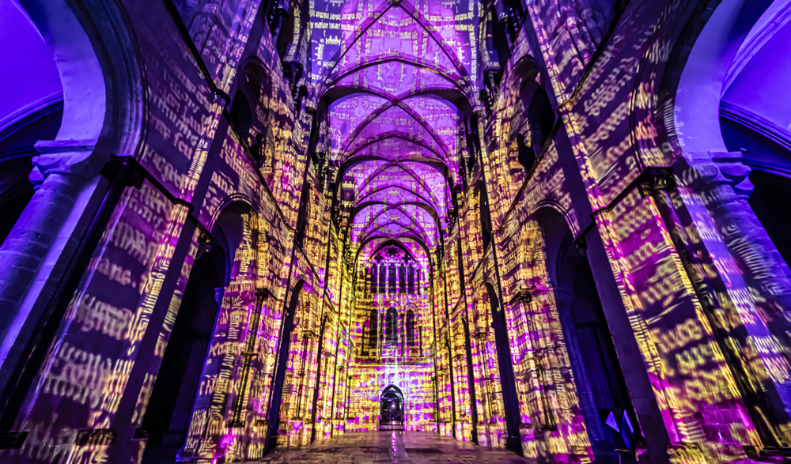
Our vision
IMAGE: Peter Walker’s 950, Chichester Cathedral (2025)
As we journeyed through our 950th anniversary in 2025, we reflected on what really matters to us here at Chichester Cathedral. We believe that it is about growing together in faith, wisdom, and compassion, and finding new ways to serve and connect with the world around us. Whether it's through worship, learning, or supporting each other, we aim to be a community that’s welcoming, joyful, and ready to make a difference.
You can read our full Vision document on the Cathedral website.

Our employee team values
Our employees came together to create values that we live by every day - Teamwork, Inclusivity, Communication, and Kindness (TICK). These aren't just words to us; they guide how we work, support one another, and interact with the world around us.
- Teamwork: We believe we’re stronger together, collaborating across departments and projects to achieve shared goals.
- Inclusivity: Everyone’s voice matters. We embrace diversity and strive to create a welcoming space where everyone feels valued and included.
- Communication: Clear, open communication is key to everything we do - whether sharing ideas, solving problems, or supporting each other.
- Kindness: We treat each other with respect and empathy, always looking out for one another and creating a positive, caring work environment.

Our commitment to our team
At Chichester Cathedral, we’re committed to living our values every day. We stay connected through regular newsletters, events, and socials, making sure everyone feels part of the team.
We listen to and encourage open discussions through one-to-one meetings and our Employee Forum, giving everyone a chance to share their ideas.
We support your professional growth with training and development opportunities to help you succeed in your role.
Inclusivity is key, with access to Disability Awareness Training, Racial Justice resources, and safeguarding, ensuring a welcoming environment for all.
JOB DESCRIPTION

Job Title: | Visual Merchandiser & Buyer
Team: | Chichester Cathedral Enterprises Ltd.
Location: | Chichester Cathedral Shop
Line Managers: | Commercial Operations Manager
Matrix Reporting: | Visitor Experience Manager
Contract: | Fixed term [24 months]
Hours: | Part-time - 0.4 FTE [14 hours per week], flexible
Salary: | £11,000 per annum [FTE £27,500]
Benefits | Generous 6.8 weeks of annual leave [pro-rata], discount in the café & shop, Employee Assistance Program, paid volunteer time, flexible working, professional development including opportunities to attend conferences, trade shows, and sector events.
Completion date: | December 2025

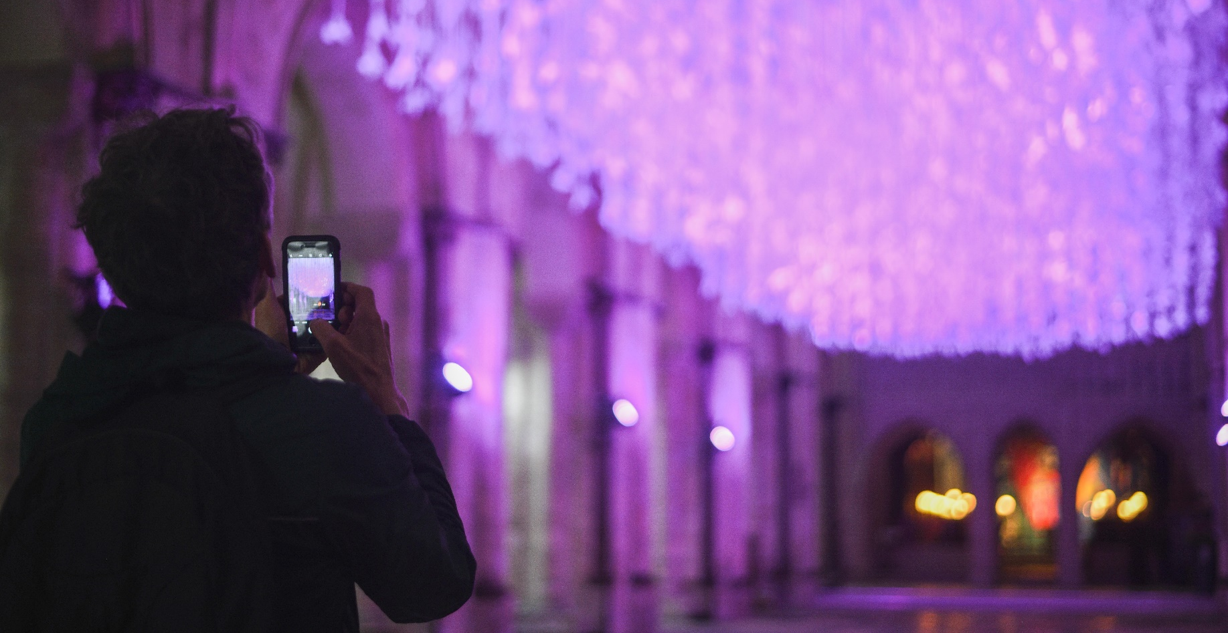
IMAGE: Peter Walker’s Peace Doves, Chichester Cathedral (2023)
1 | Job Purpose
Chichester Cathedral’s shop is a small but beautiful retail space, offering gifts and bespoke products that reflect the spirit and heritage of the Cathedral.

We are seeking a creative and commercially minded Visual Merchandiser & Buyer to help drive sales and elevate customer experience through thoughtful product selection and engaging displays. This role will work closely with the Visitor Experience Team on the presentation of the historic Treasury Collection which is displayed in the same space.

This is a flexible role, ideal for someone looking to balance other commitments.

Please note that access to the shop may occasionally be limited due to Cathedral services and events.

2 | Principal Accountabilities
- Buying & Product Selection: source and select inspiring, bespoke, and ethically produced products aligned with the Cathedral’s values, build relationships with sustainable and ethical suppliers, maintain strong product knowledge to inform buying decisions and support sales, maintain excellent profit margins through strategic buying and pricing.

- Visual Merchandising: plan and execute creative, seasonal, and thematic displays that enhance the shop’s appeal, lead shop floor moves to reflect new ranges and promotional activity, ensure the shop remains visually engaging and well-presented at all times, work closely with the Visitor Experience and Clergy teams to respond thematically to key events, liturgical seasons, and exhibitions.

- Stock Management: plan and manage stock levels to meet demand and minimise waste, process deliveries efficiently and maintain accurate stock records, monitor sales trends, and adjust stock plans accordingly.

- Team Support: support and train a team of dedicated volunteers in product presentation and merchandising standards, foster a collaborative and welcoming shop environment.

Key Performance Indicators (KPIs)
- Maintain Gross Profit Margin
  - Target: ≥ 52% across all product lines.
- Stock Turnover Efficiency
  - Aim for seasonal refresh every 10 - 12 weeks to keep the shop vibrant and relevant.

- Sales Growth on Key Lines
  - Increase revenue from top ten products by 10% year-on-year.
  - Increase conversation from visitor to customer (currently at 7%)
- Creative Merchandising Impact
  - Deliver four themed displays per year (e.g., Christmas & Advent, Easter, local events).
- Customer Engagement
  - Introduce two new locally sourced or unique products per quarter to attract repeat visits.
- Volunteer Collaboration & Retention
  - Achieve 100% positive feedback from volunteers on ease of stock management and display setup.

3 | Level of Responsibility
a | People  Support, train, and encourage a team of dedicated volunteers, support the on-going partnerships with other voluntary networks.
b | Financial Management  - responsibility for selecting and pricing products to maximize profitability while managing a purchasing budget of approximately £50,000.  - monitoring supplier costs and negotiating where appropriate to maintain value.  - tracking weekly and monthly sales against targets.  - selecting and pricing products to maintain excellent profit margins.  - reviewing sales data to identify high-performing lines and adjust buying accordingly. Avoiding overstocking or understocking to reduce waste and missed opportunities.  - identifying opportunities to boost revenue through merchandising and product selection.  - collaborating with the Visitor Experience team to align retail offers with events and exhibitions that may drive footfall.
c | Other  Producing quarterly success reports for the Board of Directors.
4 | Contacts
Internal
- work closely with lay and ordained colleagues to develop product ranges that support mission and programming.
- support and encourage a team of cathedral volunteers, working closely with the volunteer coordinator to be the main point of contact for product, training, and customer service.
- collaborate with internal teams to deliver audience development initiatives, ensuring that campaigns reach and engage key visitor and congregation segments.

External
- engage with customers, volunteers, and visitors on the cathedral floor.
- collaborate with other cathedrals, churches, and visitor attractions to share best practices and identify collaborative opportunities.

5 | Special Requirements
The post-holder is not required to be a communicant member of the Church of England but should be in sympathy with our mission.

Chichester Cathedral is committed to safeguarding of children, young people, and vulnerable adults. All staff, clergy and volunteers are expected to share this commitment and adhere to our safeguarding policies and procedures and to undertake any mandatory training including CofE safeguarding training as appropriate.

All employees, clergy and volunteers have a responsibility to ensure their own health and safety and that of colleagues, visitors, and volunteers by following our health and safety policies and procedures. Everyone is expected to take appropriate care in their work and report any concerns or incidents in line organisational guidelines.

6 | Qualifications, Skills and Experience
Essential:
- experience in visual merchandising and/or retail buying.
- excellent communication skills.
- strong commercial awareness and understanding of retail trends.
- excellent organisational and planning skills.
- creative flair and attention to detail.
- ability to work flexibly and independently.
- commitment to sustainability and ethical sourcing.
- confident use of technology is essential to streamline operational tasks, freeing up time to focus on creative merchandising, product research, and insightful reporting that enhances the shop’s visual appeal and commercial success.

Desirable:
- experience working in heritage, cultural or faith-based retail environments.
- familiarity with small shop operations and volunteer-led teams.


Commitment to Safeguarding
IMAGE: Luke Jerram, MARS, Chichester Cathedral (2024)

In accordance with Church of England’s policy, Promoting a Safer Church and the House of Bishops’ Safeguarding Policy and Practice Guidance, Chichester Cathedral is committed to the safeguarding of children, young people, and vulnerable adults who may be at risk.

The Cathedral works in partnership with the Diocese of Chichester to ensure that we operate in accordance with best practice at all times.

The care and protection of children, young people and vulnerable adults are the responsibility of the whole Cathedral community, whether clergy, staff, volunteers, contractors, or members of the congregations. Everyone who participates in the life of the Cathedral has a role to play in promoting a safe environment for all.

To learn more about Safeguarding at the Cathedral please see our website.

Commitment to Equality & Diversity

At Chichester Cathedral we are dedicated to encouraging a supportive and inclusive workplace culture amongst our employee and volunteer workforce. It is our aim to ensure that if you work here or apply to work here, on either a paid or voluntary basis you will have an equal opportunity. We are also committed to working towards an organisation workforce that is diverse and as representative of our wider community as it can be.

We respect and value each of our employees and volunteers and are committed to enabling you to be able to perform to the best of your abilities and to be your authentic self in the workplace.

How to apply
Please send your CV including your supporting statement outlining how your experience makes you a suitable candidate for our role and why you would like to work for Chichester Cathedral
to: Val Timlin, our Head of HR at:
hr@chichestercathedral.org.uk

Please note that if you are selected or interview, you will be required to complete an amended application form in line with the Church of England’s safer recruitment practice.

Key Dates:
- The closing date for applications is 9.00am on Monday 23 February 2026
- Interviews will take place in person in Chichester on Friday 27 February 2026

If you wish to discuss this role, please email:
hr@chichestercathedral.org.uk
to arrange a convenient time for discussion

